**ENERGY EFFICIENCY**

An Industrial /Practical training Project Report

Submitted to the faculty of engineering of

**JAWAHARLAL NEHRU TECHNOLOGY UNIVERSITY, HYDERABAD**

In Partial Fulfillment of the requirements for the award of the Degree of

**BATCHELOR OF TECHNOLOGY**

In

**COMPUTER SCIENCE AND ENGINEERING**

By

**J.SAMPATH KUMAR**

**(187YA0545)**

**K.HIMABINDU**

**(187Y1A0518)**

**P.VARSHINI**

**(187Y1A0555)**

**P.AKANKSHA**

**(187Y1A0502)**



**DEPARTMENT OF COMPUTER SCIENCE AND ENGINEERING**

**M L R INSTITUTE OF TECHNOLOGY AND MANAGEMENT**

**(Approved by AICTE-New Delhi, Accredited by NAAC with ‘A’ & affiliated to JNTUH, Hyderabad)**

**DUNDIGAL-500043**

**TELANGANA**

**2019-2020**

**M L R INSTITUTE OF TECHNOLOGY AND MANAGEMENT**

**(An Autonomous Institute with Permanent Affiliation to JNTUH, Hyderabad)**

**DUNDIGAL VILLAGE, QUTHBULLAPUR**

**DEPARTMENT OF**

**COMPUTER SCIENCE AND ENGINEERING**



**CERTIFICATE**

This is to certify that the Industrial/Practical Training project Report entitle “**ENERGY EFFICIENCY PREDICTION**” is a bonafide record of work carried out by **J.SAMPATH KUMAR, K.HIMA BINDU, P.VARSHINI** and **P.AKANKSHA** in partial fulfillment of the requirements for the award of the degree of **Bachelor of Technology in Computer Science and Engineering of Jawaharlal Nehru Technological University Hyderabad, Hyderabad** during the academic year 2019-2020.

Ramya

(Industrial/Practical Training coordinator)

**ACKNOWLEDGEMENT**

The satisfactory that accompanies the successful completion of any task would be incomplete without the mention of people who made it possible and whose constant guidance and encouragements crown all the efforts with success.

We feel elated to express our floral gratitude and sincere thanks to **Dr. Abdul bhashid** Head of the department, Computer science and engineering for his encouragements all the way during analysis of the project. His annotations, insinuations and criticisms and the key behind the successful completion of the project work.

We would like to take this opportunity to thank our beloved principal **Dr. K. Venkateswara Reddy.** For providing a great support for us in completing our project and giving us the opportunity for doing project.

We would like to take this opportunity to thank Smart bridge educational services PVT Ltd. For providing this training program and support for us in completing our program.

Our special thanks to the faculty of our department and programmers of our computer lab.

Finally we thank our family members, non-teaching staff, attendants and our friends, who had directly or indirectly helped and supported us in completing our project in time.

**Team members**

**J. Sampath Kumar (187y1a0545)**

**P. Varshini (187y1a0555)**

**P. Akanksha (187y1a0502)**

**K. Hima Bindu (187y1a0518)**

**ABSTRACT**

Total energy use during the life cycle of a building is a growing research field. The embodied energy makes up a considerable part of the total energy use in low energy buildings. Recycling provides the opportunity to reduce the embodied energy by using recycled materials and reusable/recyclable materials/components. The main aim is to predict the hot load and cold load. The objective considers the Relative Compactness, Surface Area, Wall Area, Roof Area, Overall Height and Orientation.

INDEX

TITLE PAGE NO

ABSTRACT

1. TITLE OF THE PROJECT 1
   1. INTRODUCTION 1
   2. OBECTIVE OF RESEARCH 3
   3. PROBLEM STATEMENT 3
   4. INDUSTRY PROFILE 3
2. REVIEW OF LITERATURE 4
3. DATA COLLECTION 5
4. METHODOLOGY 6
   1. EXPLARATORY DATA ANALYSIS 7
   2. DATA MODELING 8
5. REFERENCES
6. CONCLUSION

### PROJECT REPORT

### ENERGY EFFICENCY USING DECISION TREE

**1.1 Introduction:**

Python is a popular programming language. It is used for web development (server-side), software development, mathematics, system scripting. Python is available on a wide variety of platforms including Linux and Mac OS X. Python has a simple syntax similar to the English language. Python has syntax that allows developers to write programs with fewer lines than some other programming languages.

Artificial intelligence is the intelligence demonstrated by machines, in contrast to the intelligence displayed by humans.

Artificial Intelligence is a way of making a computer, a computer-controlled robot, or a software think intelligently, in the similar manner the intelligent humans think. The aim of Artificial Intelligence is to develop the machines to perform the tasks in a better way than the humans.

The intelligence is intangible. It is composed of:

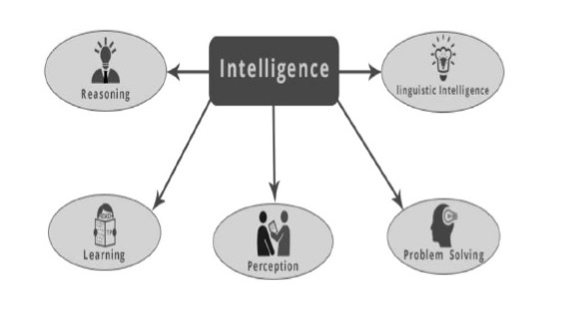

**1.2 Objective of research**

The main objective of energy efficiency is used estimation of energy performance of residential buildings. The criteria’s considered in these are relative compactness, surface area, wall area and so.

**1.3 Problem statement**

To determine the output variables of HL & CL of residential buildings. In order to estimate the required cooling and heating capacities, architects and building designers need information about the characteristics of the building and of the conditioned space (for example occupancy and activity level). For this reason, we will investigate the effect of eight input variables: (RC), surface area, wall area, roof area, overall height, orientation, glazing area, and glazing area distribution, to determine the output variables HL and CL of residential buildings.

To solve these predictions we must use some algorithms. Here we used Decision Tree algorithm for determination of hot and cold load. Decision tree algorithm falls under the category of supervised learning. They can be used to solve both regression and classification problems. Decision tree uses the tree representation to solve the problem in which each leaf node corresponds to a class label and attributes are represented on the internal node of the tree. It takes the features of the building of different size and shapes and determines the hot load and cold load.

**1.4 Industry profile**

The value of machine learning technology has been recognized by companies across several industries that deal with huge volumes of data. By leveraging insights obtained from this data, companies are able work in an efficient manner to control costs as well as get an edge over their competitors. This is how some sectors / domains are implementing machine learning -

**Financial Services**

Companies in the financial sector are able to identify key insights in financial data as well as prevent any occurrences of financial fraud, with the help of machine learning technology. The technology is also used to identify opportunities for investments and trade. Usage of cyber surveillance helps in identifying those individuals or institutions which are prone to financial risk, and take necessary actions in time to prevent fraud.

**Marketing and Sales**

Companies are using machine learning technology to analyze the purchase history of their customers and make personalized product recommendations for their next purchase. This ability to capture, analyze, and use customer data to provide a personalized shopping experience is the future of sales and marketing.

**Government**

Government agencies like utilities and public safety have a specific need FOR Ml, as they have multiple data sources, which can be mined for identifying useful patterns and insights. For example sensor data can be analyzed to identify ways to minimize costs and increase efficiency. Furthermore, ML can also be used to minimize identity thefts and detect fraud.

**Healthcare**

With the advent of wearable sensors and devices that use data to access health of a patient in real time, ML is becoming a fast-growing trend in healthcare. Sensors in wearable provide real-time patient information, such as overall health condition, heartbeat, blood pressure and other vital parameters. Doctors and medical experts can use this information to analyze the health condition of an individual, draw a pattern from the patient history, and predict the occurrence of any ailments in the future. The technology also empowers medical experts to analyze data to identify trends that facilitate better diagnoses and treatment.

**Transportation**

Based on the travel history and pattern of traveling across various routes, machine learning can help transportation companies predict potential problems that could arise on certain routes, and accordingly advise their customers to opt for a different route. Transportation firms and delivery organizations are increasingly using machine learning technology to carry out data analysis and data modeling to make informed decisions and help their customers make smart decisions when they travel.

**Oil and Gas**

This is perhaps the industry that needs the application of machine learning the most. Right from analyzing underground minerals and finding new energy sources to streaming oil distribution, ML applications for this industry are vast and are still expanding.

**2. Review of Literature**

He considered Heating Load and Cooling Load as response variables. First of all He calculated the correlation between these two response variables and other variables and also studied the correlation among all the variables. He also performed an analysis on other variables in the dataset and studied the significance of these variables to model the linear regression. Heating Load and Cooling Load depend on same variables because of high correlation. The variables which play an important part in predicting their values are Relative Compactness, Surface Area, Wall Area, Overall Height, Glazing Area and Glazing Area Distribution.

**3. Data collection**

The data which is given to the algorithm plays a major role in determination of hot and cold load. So, it is important to find the correct suitable dataset to our problem. The energy analysis using 12 different building shapes is simulated in Ecotect. The buildings differ with respect to Glazing Area, Glazing Area Distribution and Orientation, amongst other parameters. The dataset comprises of 768 samples and 8 features aiming to predict one real valued response. The dataset made use of the predictor variables and response variables i.e. the predictor variables are 8 features and the response variables are Heat load and cold load. The eight features are:

1. Relative Compactness
2. Surface Area
3. Wall Area
4. Roof Area
5. Overall Height
6. Orientation
7. Glazing Area
8. Glazing Area Distribution

**4. Methodology**

**4.1 Exploratory Data Analysis**

On the data exploration, we will see the distribution of each variable using a histogram. In the histogram, the horizontal axis is the data of the feature while the vertical axis is the frequency of occurrence. The correlation test is used to evaluate the relationship between two numerical variables. If two variables have a correlation coefficient, then the two variables are numerical variables, while the remainders are categorical variables.

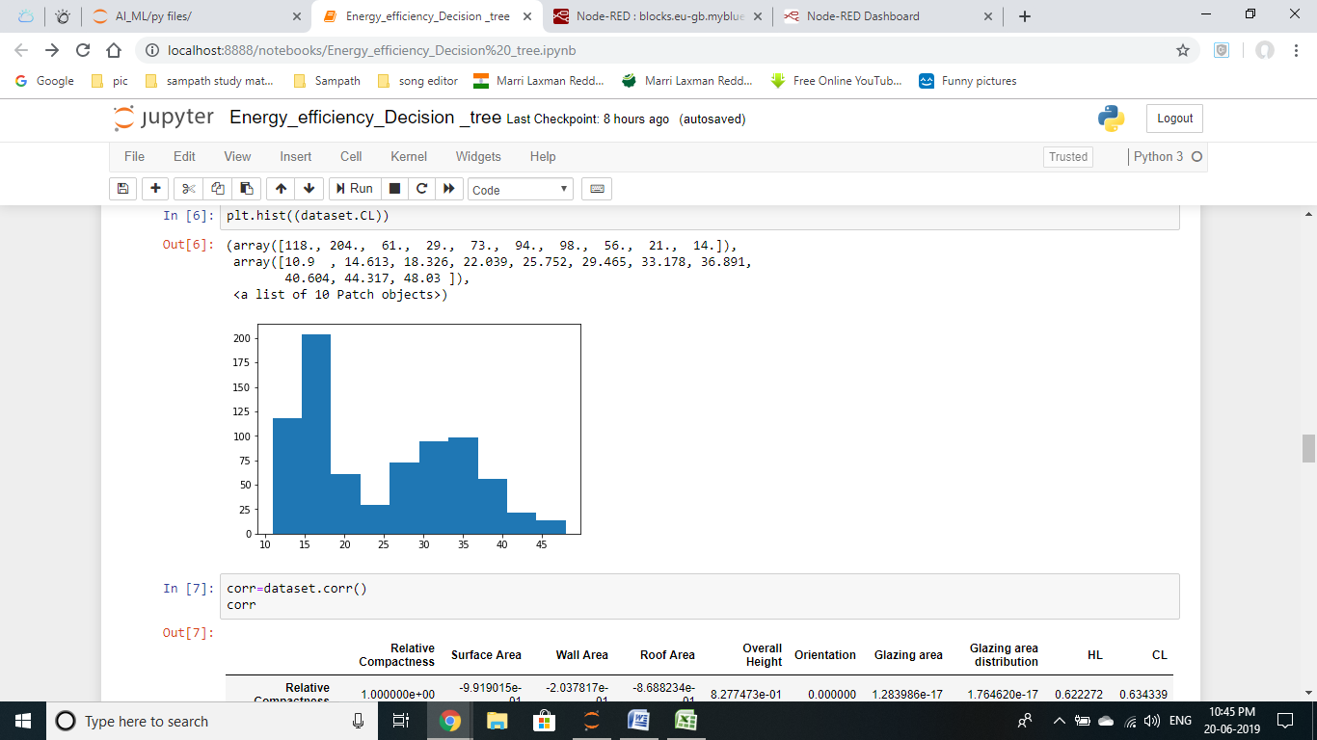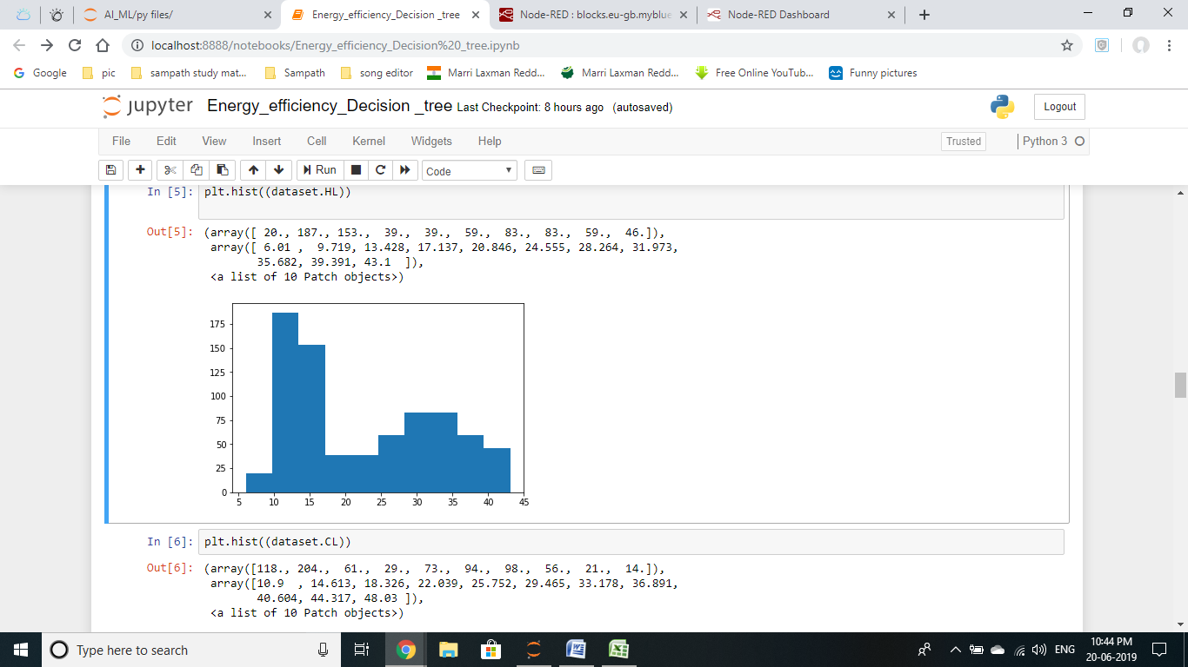

Fig. 4.1 Heat loading Fig. 4.2 Cold loading

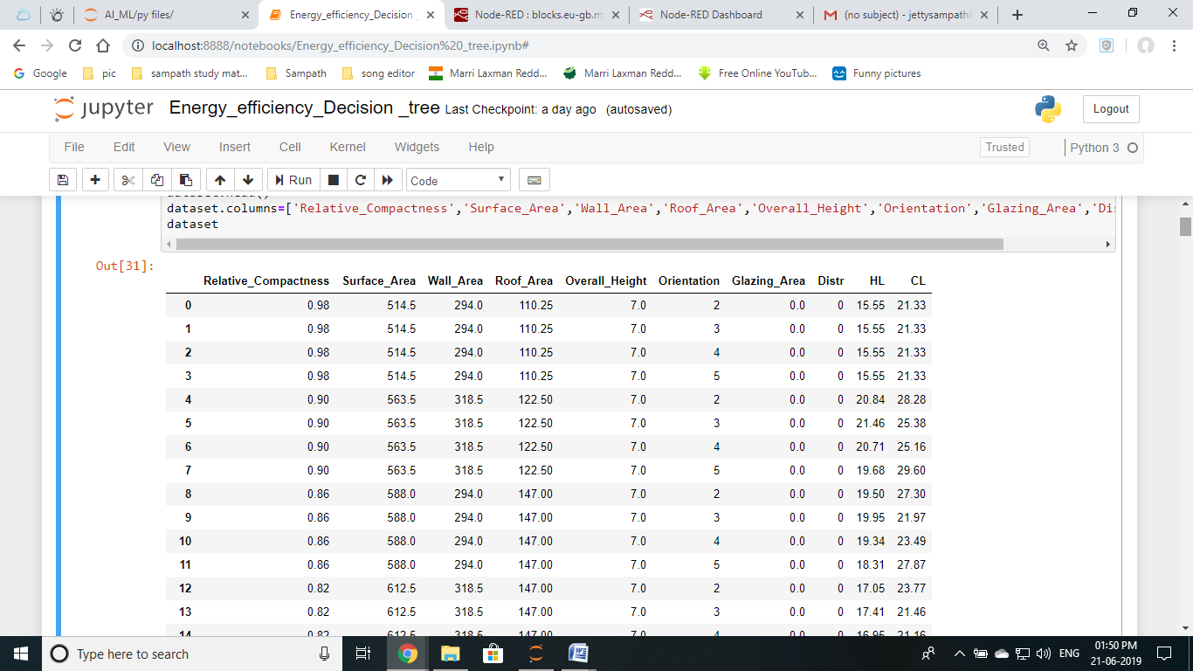

Fig 4.3 Dataset used in the algorithm

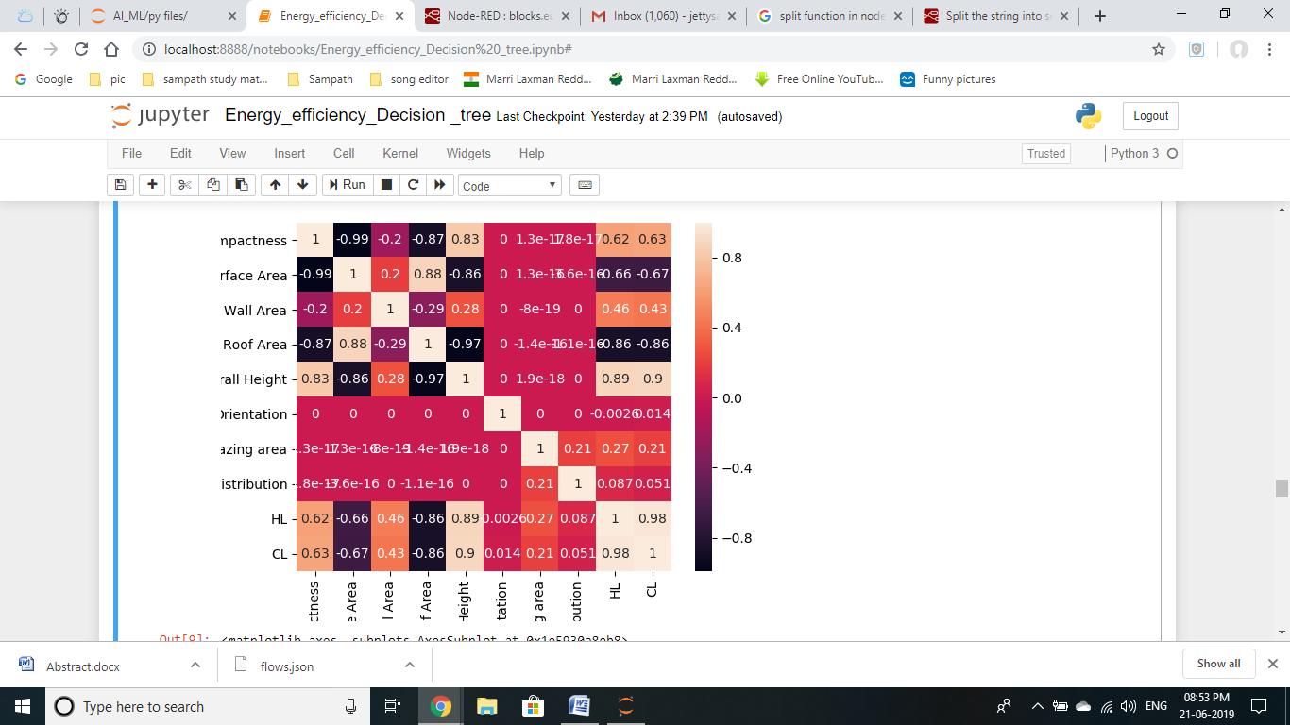

Fig 4.4 Heat Map

**4.2 Data modeling using supervised ML techniques:**

In this project in order to predict the hot load and cold load we have performed the decision tree algorithm. This is a machine learning classification algorithm which classifies the input based on Relative Compactness, Surface Area, Wall Area, Roof Area, Overall Height and Orientation.

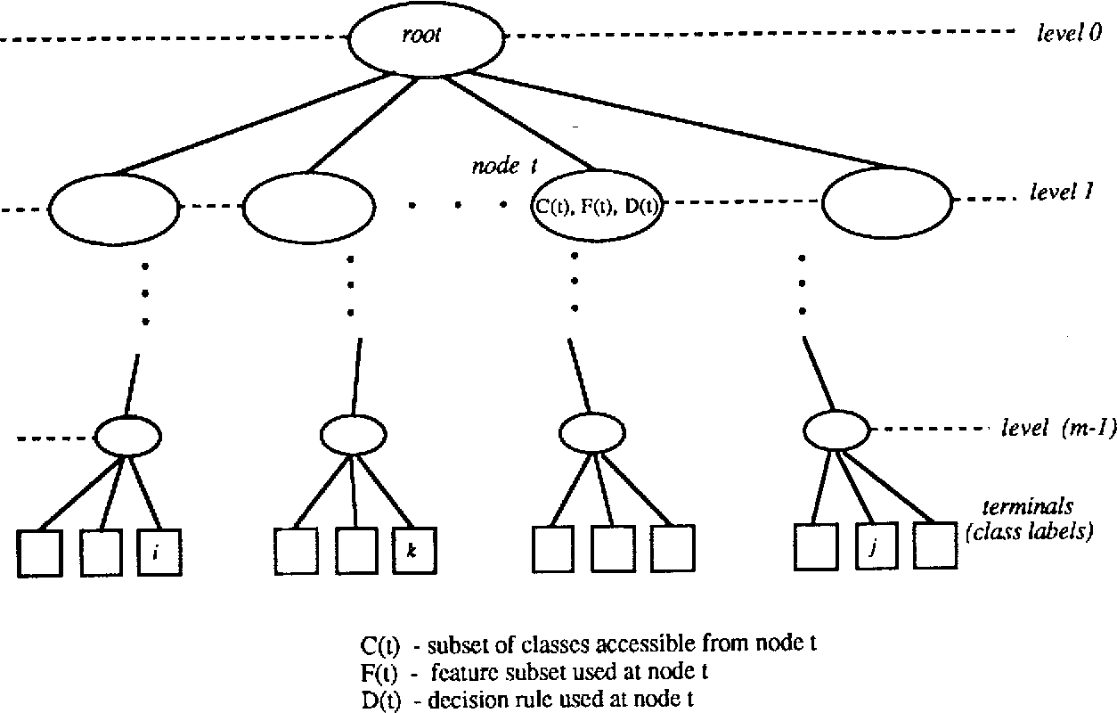

Fig 4. Demonstration of Decision tree methodology

**5. References:**

1. <https://www.kaggle.com/>
2. <https://www.youtube.com/>
3. <https://www.wikipedia.org/>
4. <https://www.w3schools.com/>
5. [https://www.geeksforgeeks.org](https://www.geeksforgeeks.org/)/
6. **Conclusion:**

The model we perform is to predict the Heating Load and Cooling Load with R2 score >= 97%. The predict the Heating Load and Cooling Load values with the optimum R2 score of 84.7% and 92.1% respectively.